Pokhara University

Level: Bachelor | Semester – Fall | Year : 2010
Programme: BE |  | Full Marks : 100
 |  | Pass Mark : 45
Course: Engineering Mathematics II |  | Time : 3 hrs

Candidates are required to give their answers in their own words as far as practicable.
The figures in the margin indicate full marks.

Attempt all the questions.

1. | - Find the shortest distance between the lines 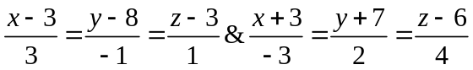 also find the equation of the line of shortest distance.  - Find the equation of the sphere having the circle 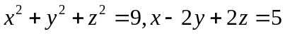as a great circle. Determine its centre and radius. | 8  7
2. | - Find the minimum value of f (x ,y, z) = 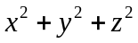 such that x + y + z = 3a².  - Show that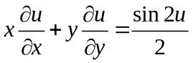, where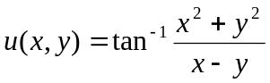. | 8  7
3. | - Change the order of integration and hence evaluate 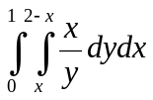.  - Evaluate the integral 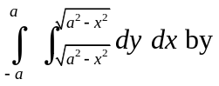 Changing into polar Co-ordinates. | 7  8
4. | - Solve the differential equation:  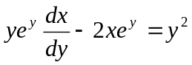  - Solve y¹¹-y¹-2y=3e^{2x}. | 7  8
5. | - Solve by power series method 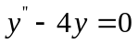.  OR  Write the Bessels function of first kind of order n. Prove that 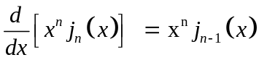.  - Find the solution of 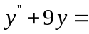 sec 3x by using variation of parameter. | 7  8
6. | - Define laplace Transform Evaluate  ( i ) L (t² coswt) ( ii ) 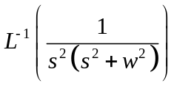  - Solve the following initial value problem by the method of Laplace transformation 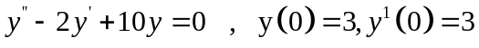 | 8  7
7. | Solve the following Problems:  - Write the general equation of a cone with it’s vertex at the origin.  - Solve 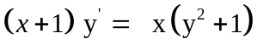  - Find 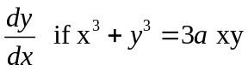. Using partial derivative method.  - Find the Laplace transform of 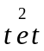.  - Find the equation of sphere whose centre is at (1,3,2) and radius 3. | 2×5

